

**BHARATI VIDYAPEETH**

**(Deemed to be University)**

**INSTIUTE OF MANAGEMENT AND ENTREPRENEURSHIP DEVELOPMENT**

**Navi Mumbai**

A

Project

On

**Blackjack Game**

Submitted to

**“Bachelor of Computer Application(B.C.A Sem-VI)”**

Submitted By

Aditya Kawale

Kanishk Kargutkar

Gaurav Marathe

Dhruvkumar Mishra

**BATCH: 2017-2020**

Under the guidance of

**Prof. Sudeshna Roy**



**BHARATI VIDYAPEETH**

**(Deemed to be University)**

**INSTIUTE OF MANAGEMENT AND ENTREPRENEURSHIP DEVELOPMENT**

**Navi Mumbai**

**CERTIFICATE**

This is to certify that the project titled **___________** is successfully doneby  
**Mr./Ms. ___________** during BCA SEM VI of his/her course in partial fulfilment of **Bachelor of Computer Application** under the **Bharati Vidyapeeth (Deemed to be University) ,** Navi Mumbai carried out by him/her under our guidance and supervision.

**External Examiner Internal**

(Signature & Date) (Signature & Date)



**BHARATI VIDYAPEETH**

**(Deemed to be University)**

**INSTIUTE OF MANAGEMENT AND ENTREPRENEURSHIP DEVELOPMENT**

**Navi Mumbai**

**CERTIFICATE**

This is to certify that the project titled **___________** is successfully done by  
**Mr. ___________** during BCA SEM VI of his/her course in partial fulfilment of **Bachelor of Computer Application** under the **Bharati Vidyapeeth (Deemed to be University) ,** Navi Mumbai carried out by him/her under our guidance and supervision during academic year 2019-20.

**Dr. Anjali Kalse**

**Declaration**

I hereby solemnly declare that the project entitled “ Blackjack Game” is an original work done by me under the guidance and supervision of Prof. Sudeshna Roy submitted to the Bharati Vidyapeeth (Deemed to be University)in partial fulfilment of the requirement for the award of Bachelor of Computer Application(SEM VI) during academic year 2019-2020.

I further declare that, to the best of my knowledge, this report or any part of the report is not submitted in this University or in any other University.

**Mr. Student Name**

(Signature & Date)

**Acknowledgment**

I avail this opportunity to express my sincere and deep gratitude to many who are a factor in helping me gain the knowledge and experience during the project and throughout the course.

I have great pleasure in presenting this project. The completion of this project is not merely due to only my own efforts but also due to the guidance given by our professors.

I am thankful to our project guide Prof. Sudeshna Roy for her support. I also thank Dr. Anjali Kalse, Incharge Director and respected faculty members for their kind support and help throughout the entire course.

Finally I express my deep regards to all of those who stretch their helping hands in the execution of my project.

**TABLE OF CONTENTS**

|  |  |  |
| --- | --- | --- |
| **Sr. No.** | **Topics** | **Page No.** |
|  | **Abstract** |  |
| **1** | **Introduction** |  |
| 1.1 | Problem Description |  |
| 1.2 | Domain Knowledge |  |
| 1.3 | Project Aim and Objective |  |
| 1.4 | Scope of the Project |  |
| **2** | **System Study** |  |
| 2.1 | Software Requirement Specification |  |
| 2.2 | Existing system |  |
| 2.3 | Proposed System |  |
| 2.4 | Software Tool Used |  |
| **3** | **System Analysis and Design** |  |
| 3.1 | Software Requirement |  |
| 3.2 | Hardware Requirement |  |
| 3.3 | Algorithm/Flowchart |  |
| 3.4 | Data Flow Diagram |  |
| 3.5 | Estimation and Planning |  |
| **4** | **System Implementation** |  |
| 4.1 | Module Description |  |
| 4.2 | Source Code |  |
| 4.3 | Screen Shot |  |
| **5** | **Conclusion** |  |
| 5.1 | Limitation |  |
| 5.2 | Enhancement |  |
| **6** | **References** |  |
| 6.1 | Bibliography |  |
| 6.2 | Webliography |  |

**INTRODUCTION**

**1.1 Problem description**

* To create a system that utilizes multiple tools and wraps them together into a functioning website. These tools include a server and client sided scripting language, a database and CSS.
* This project aims at creating a card game known as Blackjack.
* Blackjack is a card game in which players bets against a dealer. The user must play by the rules but also make skillful bets in order to win as much as possible. The program must not rely on an unlimited and infallible memory for cards that have been dealt.
* The website must utilize most of the base website building knowledge learned during the student’s university course.

**1.2 Domain knowledge**

* The context of this program is to plan, design and build Blackjack, in which the user can improve their skills and knowledge of the game, and familiarize themselves with the basic strategy of the game without losing real money.
* The aforementioned basic strategy refers to the optimal decision-making plays during each round without any regard to the cards played in prior ones. This strategy will be explored more thoroughly in the Background section of the report.
* A database must be used to store user data.
* All the modules inside the website must be on a single page.

**1.3 Project aim and objective**

* The Aim of this project is to create a working BlackJack game.
* The game should be user friendly and it should follow the standard Blackjack rules to provide an enjoyable gaming experience.
* Blackjack is a card game played between two people, the player and the dealer.
* The goal is to achieve the maximum possible score (21) without going ‘bust’ (Above 21).
* To create a working database that can be updated along with the user’s bets.

**1.4 Scope of the project**

* It is a single player game against a CPU
* The player gains double the money that he bets if he wins
* The goal is to earn more money than they had before.

The website should be user friendly and it should follow the standard Blackjack rules to provide an enjoyable gaming experience.

In order to achieve this, the objectives of the project are as follows:

**System Study**

**2.1 Software Requirement Specification**

A software is a document that captures complete description about how the system is expected to perform.

Some of the qualities of SRS are: -

* Correct
* Unambiguous
* Complete
* Verifiable
* Modification
* Traceable
* Stability

**2.2 Existing system**

* Most online websites require real money to play.

**2.3 Proposed System**

* This website doesn’t require real money.

**2.4 Software Tool Used**

1. Operating System: Windows 10
2. Programming languages: html, CSS, JavaScript, php, MySQL
   * + front end: HTML, CSS, JAVASCRIPT
     + back end: MySQL, PHP, JAVASCRIPT

**System Analysis and Design**

1. **Software requirements**

* Operating system – Windows 10, Ubuntu 14.4+ OSX Yosemite 10.10
* Any IDE to edit the code
* Wamp server
* Updated browsers which support CSS3 and HTML5

1. **Hardware requirement**
   * + HDD : 100MB
     + RAM : 128 MB
     + CPU : Intel Pentium 4 or later
2. **Algorithm/Flowchart**

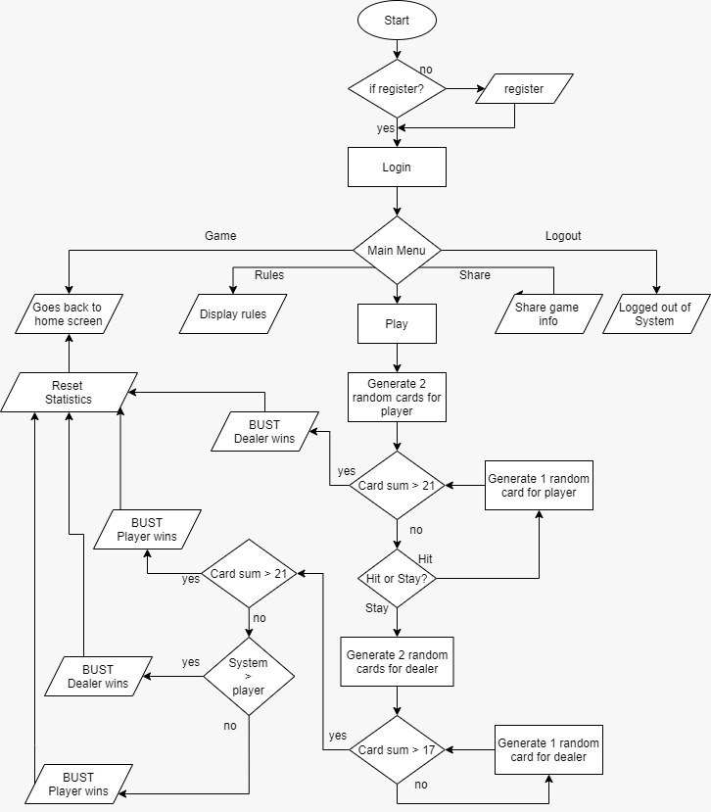

1. **Data Flow Diagram**

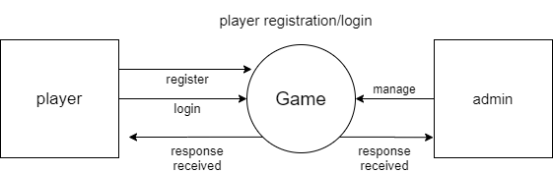

1. **Estimation and Planning**

No of weeks

**System Implementation**

1. **Module Description**
2. Registration and login

* register.php : The user cannot play unless he creates an account. The following data must be entered before playing : Username, Email and Password
* validate.html : Works on the login form by verifying if the user has inputted the correct username and password before allowing him to login.
* logout.php : Allows the user to log out of the system.
* User_details.sql : A manually programmed database file which can be imported on the server to run the website locally through XAMPP.

1. User interface

* index.css : All front end CSS is stored here.
* index.php : The actual website which runs through XAMPP.

1. Game Algorithm

* Deck.js : The BlackJack game is coded here.
* shuffle(): Shuffles the deck of cards using Durstenfeld’s shuffle algorithm.
* setValue(): Sets a score to the card object.
* createDeck() : Creates a deck of cards using the card objects.
* checkVictory() : Finalizes and checks if either the user or the dealer has successfully passed one of the given victory conditions.
* disableButtons(): Disables specified HTML buttons.
* checkBustPlayer() and checkBustDealer() : Checks if player or dealers have busted before returning a value to checkVictory().
* playerTurn and dealerTurn() : Places a card inside the div element for either the dealer side or player side depending on their turns.
* playerHand and dealerHand() : Pops a card from the deck to and places it inside either the players hand or dealers hand depending on their turns.
* playerStand() : Checks if player is ready to place his hand down then this function checks who won.
* startGame() : The function which runs when the PLAY button is clicked.

.

1. **Source Code**

**Deck.js :**deck = new Array();

suits = ["S", "D", "C", "H"];

ranks = ["A", "2", "3", "4", "5", "6", "7", "8", "9", "10", "J", "Q", "K"];

playerTotal = 0;

dealerTotal = 0;

divDealerIncrement = 1;

divPlayerIncrement = 1;

document.cookie = "user_victory=false";

function shuffle(array) {

/*

* https://stackoverflow.com/a/12646864

* Randomize array element order in-place.

* Using Durstenfeld shuffle algorithm.

*/

for (var i = array.length - 1; i > 0; i--) {

var j = Math.floor(Math.random() * (i + 1));

var temp = array[i];

array[i] = array[j];

array[j] = temp;

}

}

function createDeck() {

//var img = document.createElement("img");

for (suitsIndex = 0; suitsIndex < suits.length; suitsIndex++) {

for (ranksIndex = 0; ranksIndex < ranks.length; ranksIndex++) {

card = {};

card.suit = suits[suitsIndex];

card.rank = ranks[ranksIndex];

card.imagePath = "Cards PNG\\" + card.rank + card.suit + ".png";

card.value = setValue();

//document.getElementById(card).className += "cards";

deck.push(card);

}

}

}

function setValue() {

if (card.rank == "J" || card.rank == "Q" || card.rank == "K") {

return 10;

} else if (card.rank == "A" && playerTotal < 21) {

return 11;

} else if (card.rank == "A" && playerTotal > 21) {

if (playerTotal > 21)

return 1;

else {

/*Ace must be either 1 or 11 */

return 10;

}

} else {

return parseInt(card.rank);

}

}

function disableButtons(str) {

document.getElementById("hit").style.visibility = str;

document.getElementById("stand").style.visibility = str;

if (str == "hidden") {

document.getElementById("retry").style.visibility = "visible";

} else {

document.getElementById("retry").style.visibility = "hidden";

}

}

function checkBustPlayer() {

if (playerTotal > 21) {

//document.getElementById("playerSide").innerHTML += "<BR> BUST!";

disableButtons("hidden");

checkVictory();

return true;

} else {

return false;

}

}

function checkBustDealer() {

if (dealerTotal > 21) {

//document.getElementById("playerSide").innerHTML += "<BR>DEALER BUST!";

checkVictory();

return true;

} else {

return false;

}

}

function playerHand() {

playerCards = {};

if (!checkBustPlayer()) {

playerCards = deck.pop();

playerTotal += playerCards.value;

}

}

function setImage(img, setDiv) {

cardImage = document.createElement("img");

cardImage.src = img;

document.getElementById(setDiv).appendChild(cardImage);

}

function playerTurn() {

playerHand();

divPlayer = "playerSide" + divPlayerIncrement;

setImage(playerCards.imagePath, divPlayer);

/*document.getElementById(divPlayer).innerHTML += "<BR>";

document.getElementById(divPlayer).innerHTML += playerCards.rank + playerCards.suit;*/

document.getElementById('total').innerHTML = " Total : " + playerTotal;

divPlayerIncrement++;

checkBustPlayer();

}

function playerStand() {

disableButtons("hidden");

while (dealerTotal < 17) {

dealerTurn();

}

checkVictory();

}

function dealerHand() {

dealerCards = {};

if (!checkBustDealer()) {

dealerCards = deck.pop();

dealerTotal += dealerCards.value;

console.log(dealerCards.suit);

}

}

function dealerTurn() {

dealerHand();

divDealer = "dealerSide" + divDealerIncrement;

setImage(dealerCards.imagePath, divDealer);

/*document.getElementById(divDealer).innerHTML += "<BR>";

document.getElementById(divDealer).innerHTML += dealerCards.rank + dealerCards.suit;*/

//document.getElementById(divDealer).innerHTML += " Total : " + dealerTotal;

divDealerIncrement++;

checkBustDealer();

}

function checkVictory() {

if (playerTotal > 21) {

document.getElementById("victory_label").innerHTML = "Dealer wins!";

} else if (dealerTotal > 21) {

document.cookie = "user_victory=true";

document.getElementById("victory_label").innerHTML = "Player wins!";

} else if (playerTotal > dealerTotal && (!checkBustPlayer())) {

document.cookie = "user_victory=true";

document.getElementById("victory_label").innerHTML = "Player wins!";

} else if (dealerTotal > playerTotal && (!checkBustDealer())) {

document.cookie = "user_victory=false";

document.getElementById("victory_label").innerHTML = "Dealer wins!";

} else if (playerTotal == dealerTotal) {

document.getElementById("victory_label").innerHTML = "PUSH!";

//Game resets -> Deal beings again with previous money added to total

}

}

function startGame() {

disableButtons("visible");

document.getElementsByClassName('bets').visibility = "hidden";

createDeck();

shuffle(deck);

dealerTurn();

playerTurn();

dealerTurn();

playerTurn();

}

**Index.php :**

<html>

<head>

<title>Blackjack</title>

<meta name="viewport" content="width=device-width, initial-scale=1">

<!--Scale window according to device-->

<link rel="stylesheet" href="index.css?v=<?php echo time(); ?>">

<script src='deck.js' type='text/javascript'></script>

</head>

<body>

<script>

document.cookie = "new_money=0";

</script>

<?php

session_start();

$connect = mysqli_connect("localhost", "root", "", "blackjackUD"); # connection to db

//$_SESSION = []; //Form reset debug

?>

<header class="nav_bar">

<img class="logo" src="Webphotos\logo2.png">

<nav class="navbar">

<ul class="nav_links">

<li class="home"><a href="#game_section">GAME</a></li>

<li class="tutorial"><a href="#section_rules">RULES</a></li>

<li class="about"><a href="#section_about">SHARE</a></li>

</ul>

</nav>

<?php

if (isset($_SESSION['username'])) {

echo "<a class='cta' href='database\\logout.php'><button class='login' style='width:auto'>";

echo "LOGOUT";

} else {

echo "<a class='cta'><button class='login' onclick=\"document.getElementById('id01').style.display='block'\" style='width:auto' id='login'>";

echo "Login";

}

?>

</button></a>

</header>

<div class="game_space" id="game_section">

<div class="game_part">

<?php

if (isset($_SESSION['username'])) {

echo "<button onclick=\"this.style.visibility='hidden'; startGame()\" id='game' class='play'>PLAY</Button>";

echo " <div>\n";

echo " <label class='bets_label' id='bets_label'></label>\n";

echo " </div>\n";

echo " <div class=\"bets_area\">\n";

echo " <button onclick=addMoney(100) class='bets'>100</button>\n";

echo " <button onclick=addMoney(500) class='bets'>500</button>\n";

echo " <button onclick=addMoney(1000) class='bets'>1000</button>\n";

echo " </div>\n";

echo " <!--<div class=\"bets_area_remove\">\n";

echo " <button onclick=addMoney(-100) class='bets'>-100</button>\n";

echo " <button onclick=addMoney(-500) class='bets'>-500</button>\n";

echo " <button onclick=addMoney(-1000) class='bets'>-1000</button>\n";

echo " </div>-->\n";

echo " <!--Money isn't additive, fix later-->\n";

echo " <script>\n";

echo " function addMoney(money) {\n";

echo " current_money = document.getElementById('bets_label').innerHTML;\n";

echo " document.getElementById('bets_label').innerHTML = '0';\n";

echo " document.getElementById('bets_label').innerHTML = 'You bet ' + money;\n";

echo " document.cookie = \"new_money=\" + money + \";\";\n";

//echo " alert(document.cookie);\n";

echo " }\n";

echo " </script>";

} else {

echo "<button id='game' class='play'>LOGIN TO PLAY!</Button>";

}

?>

<label id='victory_label' class='victory_label'></label>

<?php

if (isset($_SESSION['username'])) {

$new_money = 0;

$new_money = $_COOKIE['new_money'];

$name = $_SESSION['username'];

$check_money = "SELECT money from user_details WHERE user_name = '$name'";

$add_money = "UPDATE user_details SET money = money + '$new_money' + '$new_money' WHERE user_name = '$name'";

$remove_money = "UPDATE user_details SET money = money - '$new_money' WHERE user_name = '$name'";

$current_money = mysqli_query($connect, $check_money);

$result = mysqli_query($connect, $check_money);

$row = mysqli_fetch_row($result);

if ($row[0] > $new_money) {

mysqli_query($connect, $remove_money);

setcookie('new_money', '0', time() + 60, '/');

} else {

//echo "<script> alert('You don't have enough money for that bet!'); </script>";

}

$user_victory = $_COOKIE['user_victory'];

if ($user_victory == "true") {

mysqli_query($connect, $add_money);

setcookie('new_money', '0', time() + 60, '/');

}

}

?>

<div>

<div id=dealerSide1 class="dCards"> </div>

<div id=dealerSide2 class="dCards"> </div>

<div id=dealerSide3 class="dCards"> </div>

<div id=dealerSide4 class="dCards"> </div>

<div id=dealerSide5 class="dCards"> </div>

<div id=dealerSide6 class="dCards"> </div>

</div>

<button onclick="playerTurn()" id="hit" value="HIT" class="action">HIT</button>

<button onclick="playerStand()" id="stand" value="STAND" class="action">STAND</button>

<button onclick="location.reload();" id="retry" value="RETRY" class="action">PLAY AGAIN</button>

<div>

<div id=playerSide1 class="pCards"> </div>

<div id=playerSide2 class="pCards"> </div>

<div id=playerSide3 class="pCards"> </div>

<div id=playerSide4 class="pCards"> </div>

<div id=playerSide5 class="pCards"> </div>

<div id=playerSide6 class="pCards"> </div>

</div>

<div class='total' id='total'>

</div>

</div>

</div>

<div class="rule_nav">

<span class="rulesnav ,position2, rborder">

<ul>

<a onclick="document.getElementById('id03').style.display='block'" style="width:auto" class="rkeys">

<li>Cards </li>

</a> <br>

<a onclick="document.getElementById('id04').style.display='block'" style="width:auto" class="rkeys">

<li>Hitting </li>

</a> <br>

<a onclick="document.getElementById('id05').style.display='block'" style="width:auto" class="rkeys">

<li>standing </li>

</a> <br>

<a onclick="document.getElementById('id06').style.display='block'" style="width:auto" class="rkeys">

<li>surrender</li>

</a> <br>

</ul>

</span>

<span class="rules" id="section_rules">

<h3>THE BASIC RULES WHEN PLAYING BLACKJACK:</h3>

<p> </p>

<ol>

<li>

<p>Blackjack starts with players making bets.</p>

</li>

<li>

<p>Dealer deals 2 cards to the players and two to himself.

</p>

</li>

<li>

<p>Blackjack card values: All cards count their face value in blackjack. Picture cards count as

10 and <br> the acecan count as either 1 or 11. Card suits have no meaning in blackjack. The

total of any hand <br>is the sum of the card values in the hand</p>

</li>

<li>

<p>Players must decide whether to stand or hit.</p>

</li>

<li>

<p>The dealer acts last and must hit on 16 or less and stand on 17 through 21.</p>

</li>

<li>

<p>Players win when their hand totals higher than dealer's hand, or they have 21 or less when

<br> the dealer busts &nbsp; (i.e., exceeds 21).

</p>

</li>

</ol>

</span>

</section>

</div>

<?php

if (isset($_SESSION['username'])) {

echo "<form onclick='database\\logout.php' method='POST'>";

echo "</form>";

} else {

echo "<div id='id01' class='modal'>";

echo " <form class='model-content' action='database\\validate.php' method='POST'>";

echo " <div class='close-sign'>";

echo " <span onclick=\"document.getElementById('id01').style.display='none'\" title='Close Modal' class='close'>

&times";

echo " </span> </div>";

echo " <br><br><br><br><br><br><br><br><br><br><br><br><br><br><br><br>";

echo " <label for='uname'> Username</label><br>";

echo " <input input type='text' name='nm' required='required' placeholder='Enter Username'><br><br>";

echo " <label for='password'> Password</label><br>";

echo " <input input type='password' name='userpassword' id='pass' required

placeholder='Enter your password'><br><br>";

echo " <button input type='submit' value=Login name='Login' class='loginbtn'> Login </button>";

echo " <p class='regi-position' onclick=\"document.getElementById('id02').style.display='block'\";>Sign up here!<p>";

echo " </div>";

echo " </form>";

echo "</div>";

} ?>

<div id="id02" class="modal">

<form class="model-content" action="database\register.php" method="POST">

<div class="close-sign">

<span onclick="document.getElementById('id02').style.display='none'" title="Close Modal" class="logclose">

&times;

</span>

</div>

<div>

<br><br><br><br><br><br><br><br><br><br><br><br><br>

<label for="nm"> Username</label><br>

<input type="text" name="nm" required><br><br>

<label for="address">E-Mail</label><br>

<input type="text" name="address" required><br><br>

<label for="password"> Password</label><br>

<input type="password" name="userpassword" id="pass" required pattern="(?=.*\d)(?=.*[a-z])(?=.*[A-Z]).{6,}" title='Your password must contain at least one uppercase or lowercase letter, 1 number and a minimum of 6 characters'><br><br>

<!--<label for="password"> Password</label><br>

<input type="password" placeholder="Enter your password" name="password" required><br><br> -->

</div>

<button type="submit" class="loginbtn"> Register </button>

</form>

</div>

<div id="id03" class="cards-rules">

<div class="cards-rules-content">

<div class="close-sign">

<span onclick="document.getElementById('id03').style.display='none'" title="Close Modal" class="close">

&times;

</span>

<h1 class="cardhead"> Card Rules</h1>

<img src="WebPhotos\card-value.png" alt="card_value" class="rules_img">

<span class="content">

All cards count their face value in blackjack. Picture cards count as 10 and the ace can count as either

1 or 11.

Card suits have no meaning in blackjack. The total of any hand is the sum of the card values in the

hand. A hand

containing a 4-5-8 totals 17. Another containing a queen-5 totals 15. It is always assumed that the ace

counts as

11 unless so doing would make your hand total exceed 21, in which case the ace reverts to a value of 1.

</span>

</div>

</div>

</div>

<div id="id04" class="cards-rules">

<div class="cards-rules-content">

<div class="close-sign">

<span onclick="document.getElementById('id04').style.display='none'" title="Close Modal" class="close">

&times;

</span>

<h1 class="cardhead"> Hitting Rules</h1>

<img src="WebPhotos\Hit.png" alt="card_value" class="rules_img">

<span class="content">

This means you want the dealer to give another card to your hand. In shoe games, indicate to the dealer

that you want a hit by making a beckoning motion with your finger or tapping the table behind your cards

with your finger. In hand-held games, scratch the edges of the cards in your hand lightly on the felt

</span>

</div>

</div>

</div>

<div id="id05" class="cards-rules">

<div class="cards-rules-content">

<div class="close-sign">

<span onclick="document.getElementById('id05').style.display='none'" title="Close Modal" class="close">

&times;

</span>

<h1 class="cardhead"> Standing Rules</h1>

<img src="WebPhotos\Stand.png" alt="card_value" class="rules_img">

<span class="content">

This means you are satisfied with the total of the hand and want to stand with the cards you have. In

shoe games, indicate that you want to stand by waving your hand over the cards, palm down. In hand-held

games, tuck your cards under the chips that you have in the betting box.

</span>

</div>

</div>

</div>

<div id="id06" class="cards-rules">

<div class="cards-rules-content">

<div class="close-sign">

<span onclick="document.getElementById('id06').style.display='none'" title="Close Modal" class="close">

&times;

</span>

<h1 class="cardhead"> Surrender</h1>

<img src="WebPhotos\Surrender.png" alt="card_value" class="rules_img">

<span class="content">

This playing option is sometimes permitted. It allows a player to forfeit the hand immediately with an

automatic loss of half the original bet. In most venues, players can surrender their initial two-card

hand only after the dealer has checked his cards and ascertained that he doesn’t have a blackjack (known

as late surrender). Once a player draws a card, the surrender option is no longer available. If the

dealer has a blackjack hand, then surrender is not available.

</span>

</div>

</div>

</div>

<footer id="section_about" class="foot">

<!--<p style="color: white; font-size: 36px">&nbsp; Contact information:</p>

&nbsp;&nbsp;&nbsp; <a href="mailto:kanishkkargutkar123@gmail.com" class="footer-a">&nbsp; kanishkkargutkar123@gmail.com</a>

&nbsp; <a href="mailto:marathegaurav364@gmail.com" class="footer-a">marathegaurav364@gmail.com</a>

&nbsp; <a href="mailto:kawaleaditya870@gmail.com" class="footer-a">kawaleaditya870@gmail.com</a>

&nbsp; <a href="mailto:mishradhruv072@gmail.com" class="footer-a">mishradhruv072@gmail.com</a>

<p></p> -->

<br>

<p class="share">Share </p>

<div>

<span class="share_icon">

<a padding-left: 7px; href="https://www.facebook.com/"><img src="Webphotos\fbwhite.png" alt="facebook"></a> &nbsp

<a padding-left: 7px; href="https://www.instagram.com/"><img src="Webphotos\insta1.png" alt="insta"></a> &nbsp

<a padding-left: 7px; href="https://twitter.com/?lang=en"><img src="Webphotos\t2.png" alt="tweet"></a> &nbsp

<a padding-left: 7px; href="https://www.whatsapp.com/\"><img src="Webphotos\whatsApp1.png" alt="Whatsapp"></a> &nbsp

</span>

</footer>

<script>

var modal1 = document.getElementById('id01');

var modal2 = document.getElementById('id02');

var modal3 = document.getElementById('id03');

var modal4 = document.getElementById('id04');

var modal5 = document.getElementById('id05');

var modal6 = document.getElementById('id06');

// When the user clicks anywhere outside of the modal, close it

window.onclick = function(event) {

if (event.target == modal1) {

modal1.style.display = "none";

}

window.onclick = function(event) {

if (event.target == modal2) {

modal2.style.display = "none";

}

window.onclick = function(event) {

if (event.target == modal3) {

modal3.style.display = "none";

}

window.onclick = function(event) {

if (event.target == modal4) {

modal4.style.display = "none";

}

window.onclick = function(event) {

if (event.target == modal5) {

modal5.style.display = "none";

}

window.onclick = function(event) {

if (event.target == modal6) {

modal6.style.display = "none";

}

}

}

}

}

}

}

</script>

</body>

</html>

**CSS :**

@font-face {

/*https://famfonts.com/games/red-dead-redemption*/

font-family: "RedDead";

src: url("fonts/CHINESER.TTF");

}

@font-face {

/*https://www.fontspace.com/category/retro*/

font-family: "Remachine";

src: url("fonts/Chelsea.TTF");

}

@font-face {

/*https://www.fontspace.com/category/retro*/

font-family: "Login";

src: url("fonts/RioGrande.TTF");

}

@font-face {

/*https://www.fontspace.com/category/retro*/

font-family: "crule";

src: url("fonts/Ranchers.TTF");

}

html {

scroll-behavior: smooth;

}

body {

box-sizing: border-box;

margin: 0;

padding: 0;

background-color: black;

background-image: url("WebPhotos\\mess_bg1.jpg");

background-attachment: fixed;

font-family: "RedDead", Arial;

}

body::-webkit-scrollbar {

width: 7px;

/* width of the entire scrollbar */

}

body::-webkit-scrollbar-thumb {

background-image: url("WebPhotos\\scroll.png");

background-repeat: no-repeat;

border-radius: 100%;

}

.navbar li,

a,

button {

font-family: "RedDead", Arial;

font-weight: 500;

font-size: 30px;

color: whitesmoke;

text-decoration: none;

}

.nav_bar {

position: -webkit-sticky;

/* Safari */

position: relative;

top: 0;

}

header {

display: flex;

justify-content: space-between;

align-items: center;

padding: 2% 3%;

position: relative;

}

.logo {

position: relative;

left: 1%;

width: 20vw;

height: 20vh;

cursor: pointer;

}

nav {

order: 1;

}

.nav_links {

list-style: none;

}

.nav_links li {

display: inline-block;

padding: 0px 20px;

}

.nav_links li a {

transition: all 0.3s ease 0s;

}

.nav_links li a:hover {

color: rgba(204, 0, 0, .75);

}

.cta {

order: 3;

cursor: pointer;

transition: all 0.3s ease 0s;

}

.list-login {

padding-left: 100px;

}

.login {

padding: 9px 25px;

background-color: rgba(204, 0, 0, .75);

color: black;

border: none;

border-radius: 50px;

cursor: pointer;

transition: all 0.3s ease 0s;

}

button {

/*Default button, change to class name*/

padding: 9px 25px;

background-color: rgba(204, 0, 0, .75);

color: black;

border: none;

border-radius: 50px;

cursor: pointer;

transition: all 0.3s ease 0s;

}

button:hover {

color: white;

}

.modal {

display: none;

position: fixed;

z-index: 1;

left: 0;

top: 0;

padding-top: 60px;

width: 100%;

height: 100%;

overflow: auto;

background-color: rgb(0, 0, 0);

background-color: rgb(0, 0, 0, 0.4);

}

.model-content {

font-family: "Login", Arial;

border-radius: 10px;

width: 25%;

height: 80%;

background-image: url('WebPhotos\\login1.jpg');

background-repeat: no-repeat;

background-size: cover;

background-position: center;

margin: auto;

}

.victory_label {

font-family: "RedDead", Arial;

}

.logclose {

/*new class*/

font-size: 60px;

position: absolute;

right: 2%;

top: -10px;

color: black;

font-weight: bold;

}

.logclose:hover,

.logclose:focus {

cursor: pointer;

color: red;

}

.close-sign {

text-align: center;

margin: 24px 0 12px 0;

position: relative;

}

.close {

font-size: 60px;

position: absolute;

right: 20%;

top: -10px;

color: black;

font-weight: bold;

}

.close:hover,

.close:focus {

cursor: pointer;

color: red;

}

.profile {

position: relative;

left: 45px;

top: 20px;

border: none;

margin: 12% 10%;

border-radius: 10%;

width: 50%;

}

label {

font-size: 24px;

padding: 12px 20px;

}

input[type=text],

input[type=password] {

background-color: rgba(192, 92, 11, 0.281);

font-size: 14px;

width: 80%;

padding: 12px 20px;

margin-top: 8px;

margin-left: 4%;

}

.loginbtn {

background-color: saddlebrown;

font-size: 20px;

position: relative;

left: 4%;

top: 20px;

}

.cancelbtn {

background-color: saddlebrown;

font-size: 20px;

position: relative;

left: 30%;

top: 20px;

}

.regi-position {

color: red;

font-size: 20px;

position: relative;

left: 55%;

top: -30px;

}

.regi-position:hover {

color: rgb(71, 14, 14);

cursor: pointer;

}

.game_space {

background-image: url("WebPhotos\\table_bg1.png");

height: 100vh;

width: 100%;

background-repeat: no-repeat;

background-size: 100% 100%;

vertical-align: top;

object-fit: contain;

position: relative;

display: flex;

}

.game_part {

position: relative;

align-content: center;

left: 50%;

top: 50%;

margin-top: -100px;

margin-left: -100px;

}

.play {

padding: 10px 25px;

border: none;

border-radius: 5px;

cursor: pointer;

transition: all 0.3s ease 0s;

}

.action {

visibility: hidden;

border-radius: 5px;

display: relative;

}

.retry {

visibility: hidden;

}

.section {

background-color: coral;

width: 100%;

height: 200%;

}

.rules {

font-family: "Remachine", Arial;

display: block;

width: 70%;

height: 50%;

margin-left: 24px;

color: white;

font-size: 24px;

}

.rulesnav {

background-image: url('WebPhotos\\vintage_bg2.jpg');

background-position: center;

background-repeat: no-repeat;

background-size: cover;

display: block;

float: right;

margin: 5% 6%;

padding: 10px 25px;

font-size: 28px;

color: blue;

}

.rules_modal {

font-family: "RedDead", Arial;

}

.myhover {

cursor: pointer;

color: yellow;

}

.position2 {

position: sticky;

top: 50%;

}

.rborder {

border-style: ridge;

border-radius: 5%;

border-color: black;

}

.rkeys {

color: rgb(82, 8, 8);

cursor: pointer;

}

.cards-rules {

display: none;

position: fixed;

z-index: 1;

left: 0;

top: 0;

padding-top: 60px;

width: 100%;

height: 100%;

overflow: auto;

background-color: rgb(0, 0, 0);

background-color: rgb(0, 0, 0, 0.4);

}

.cardhead {

position: absolute;

left: 17%;

}

.cards-rules-content {

font-family: "crule", Arial;

font-weight: 200px;

border-radius: 10px;

width: 85%;

height: 85%;

background-image: url('WebPhotos\\crule.png');

background-repeat: no-repeat;

background-size: cover;

background-position: center;

margin: auto;

}

.content {

position: relative;

font-family: "crule", Arial;

font-size: 34px;

left: 10%;

top: 70px;

display: block;

width: 70vw;

}

.rules_img {

position: relative;

left: 45px;

top: 0px;

border: none;

margin: 2% 1%;

border-radius: 10%;

width: 20%;

}

.foot {

align-items: center;

background-image: url("WebPhotos/footer_stars.png");

background-repeat: no-repeat;

background-size: cover;

display: inline-block;

height: 25%;

width: 100%;

}

.footer-a {

font-family: unset;

font-size: 20px;

}

.share {

font-family: "RedDead", Arial;

color: white;

font-size: 36px;

position: relative;

display: inline-block;

left: 41%;

}

.share_icon {

display: inline-block;

position: relative;

left: 35%;

}

.bets {

visibility: visible;

}

.bets_label {

font-family: "RedDead", Arial;

font-size: 32px;

}

.bets_area {

position: absolute;

float: left;

left: 40vw;

}

.bets_area_remove {

position: absolute;

float: right;

right: 65vw

}

/*Game section*/

.dCards {

/*background-color: yellow;*/

position: relative;

height: 15vh;

width: 5vw;

top: -35vh;

left: -33%;

margin: 10px;

float: left;

}

.pCards {

/*background-color: green;*/

position: relative;

height: 15vh;

width: 5vw;

top: 2vh;

left: -33%;

float: left;

margin: 10px;

}

img {

max-width: 100%;

max-height: 100%;

}

**Validate.php :**

<?php

session_start();

$connect = mysqli_connect("localhost","root","","blackjackUD"); # connection to db

// if($connect)

// {

// echo " connection established";

// }

// else

// {

// echo " ERROR NOT CONNECTED";

// } # just to check the connection between php and data base to verify the connectionp;

$name= $_POST['nm'];# name of the user using for the login

$Password= $_POST['userpassword']; # PASSWORD user for the login

// $a=$_POST['address'];

$name= mysqli_real_escape_string($connect,$name);# to prevent from sql injection secured form

$Password= mysqli_real_escape_string($connect,$Password);# to prevent from sql injection secured form

$query = "SELECT user_password from user_details where user_name = '$name'";

//$check = " select * from user_details where user_name= '$name' && user_password = '$Password'"; # query to chek the record exist or not in the databse

$result = mysqli_query($connect,$query) ;

//$check_rows = mysqli_num_rows($result);# l1 p1

$check_rows = mysqli_fetch_assoc($result); # check the no of rows in the database

//echo $check_rows['user_password']; # check the encrpted pasword from the database

$pass_chk = $check_rows['user_password'];

if(password_verify($Password,$pass_chk))

{

$_SESSION['username']=$name;

echo "<script>

alert('LOGIN SUCESSFUL');

location.href='../index.php';

</script>";

}

else

{

echo "<script>

alert('LOGIN Failed Please check ID or Password');

location.href='../index.php';

</script>";

}

// if ($check_rows == 1) #check the records in the table

// {

// // echo " RECORD IS PRESENT ";

// $_SESSION['username']=$name;

// echo "<script>

// alert('LOGIN SUCESSFUL');

// location.href='mainpage.php';

// </script>";

// //header('location:newglowing.html');

// }

// else

// {

// echo "<script>

// alert('LOGIN Failed Please check ID or Password');

// location.href='mainpage.php';

// </script>";

// // header('location:login.html');

// }

?>

**Register.php :**

<?php

session_start();

$connect = mysqli_connect("localhost","root","","blackjackUD"); # connection to db

// if($connect)

// {

// echo " connection established";

// }

// else

// {

// echo " ERROR NOT CONNECTED";

// } # just to check the connection between php and data base to verify the connectionp;

$n=$_POST['nm'];# name of the user using for the login

$p=$_POST['userpassword']; # PASSWORD user for the login

$a=$_POST['address'];

$n= mysqli_real_escape_string($connect,$n);# to prevent from sql injection secured form

$p= mysqli_real_escape_string($connect,$p);# to prevent from sql injection secured form

$a= mysqli_real_escape_string($connect,$a);# to prevent from sql injection secured form

$p = password_hash($p,PASSWORD_BCRYPT);

$check_email = "SELECT * from user_details WHERE user_address = '$a'";

$checkusername="SELECT * from user_details WHERE user_name = '$n'";

$username = mysqli_query($connect,$checkusername);

$email = mysqli_query($connect,$check_email);

$nuser = mysqli_num_rows($username);

$emailcount = mysqli_num_rows($email);

$insert = "SELECT * from user_details where user_name = '$n' && user_password = '$p' && user_address = '$a' "; # query to chek the record exist or not in the databse

$result = mysqli_query($connect,$insert) ;

$check_rows = mysqli_num_rows($result); # check the no of rows in the database

if($emailcount > 0 )

{

echo "<script>

alert('E-mail already exists! Please enter a new E-mail. ')

location.href='../index.php'

</script>";

// echo " test if mail exists";

}

elseif ($nuser > 0)

{

// echo " user name exist";

echo "<script>

alert('Username alredy exist! Please enter a unique Username!);

location.href='../index.php';

</script>";

// //header('location:login.html');

}

else

{

$insert = " INSERT into user_details(user_name , user_password , user_address) values ('$n' , '$p' , '$a')";

mysqli_query($connect,$insert); #

//echo "Your ID ".$connect-> insert_id;# to show Last inserted ID

echo "<script>

alert('REGISTERED')

location.href='../index.php';

</script>";

// echo "registerd";

//header('location:login.html');

}

?>

**Logout.php :**

<?php

session_start();

session_destroy();

$_SESSION = [];

echo "<script>

alert('Logout Succesful');

location.href='../index.php';

</script>";

?>

1. **Screen Shot**

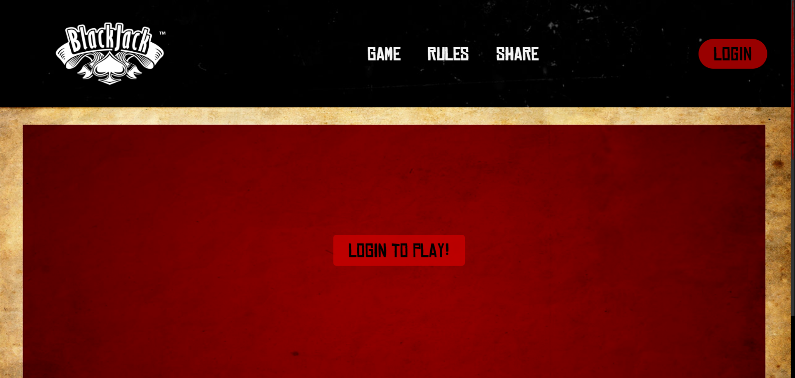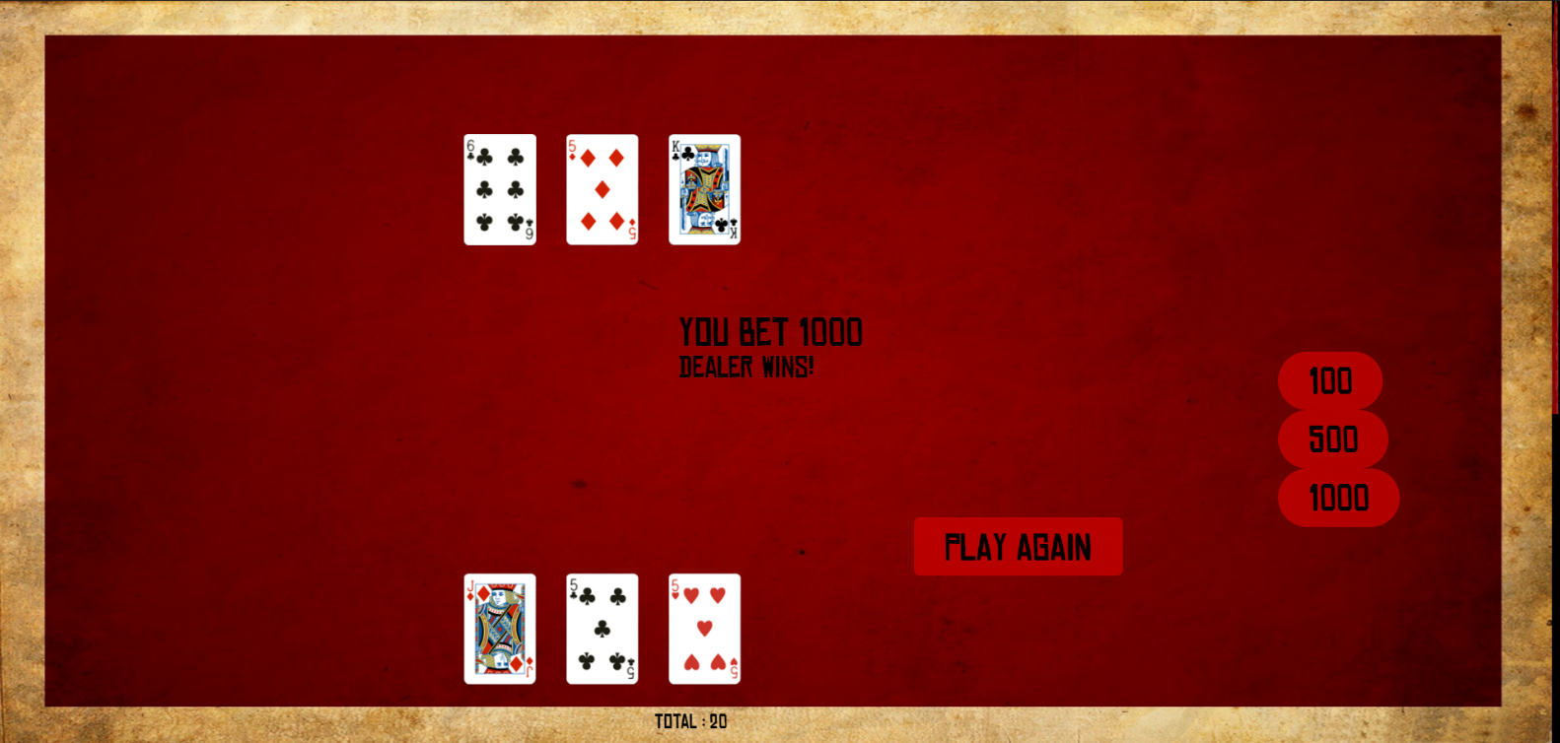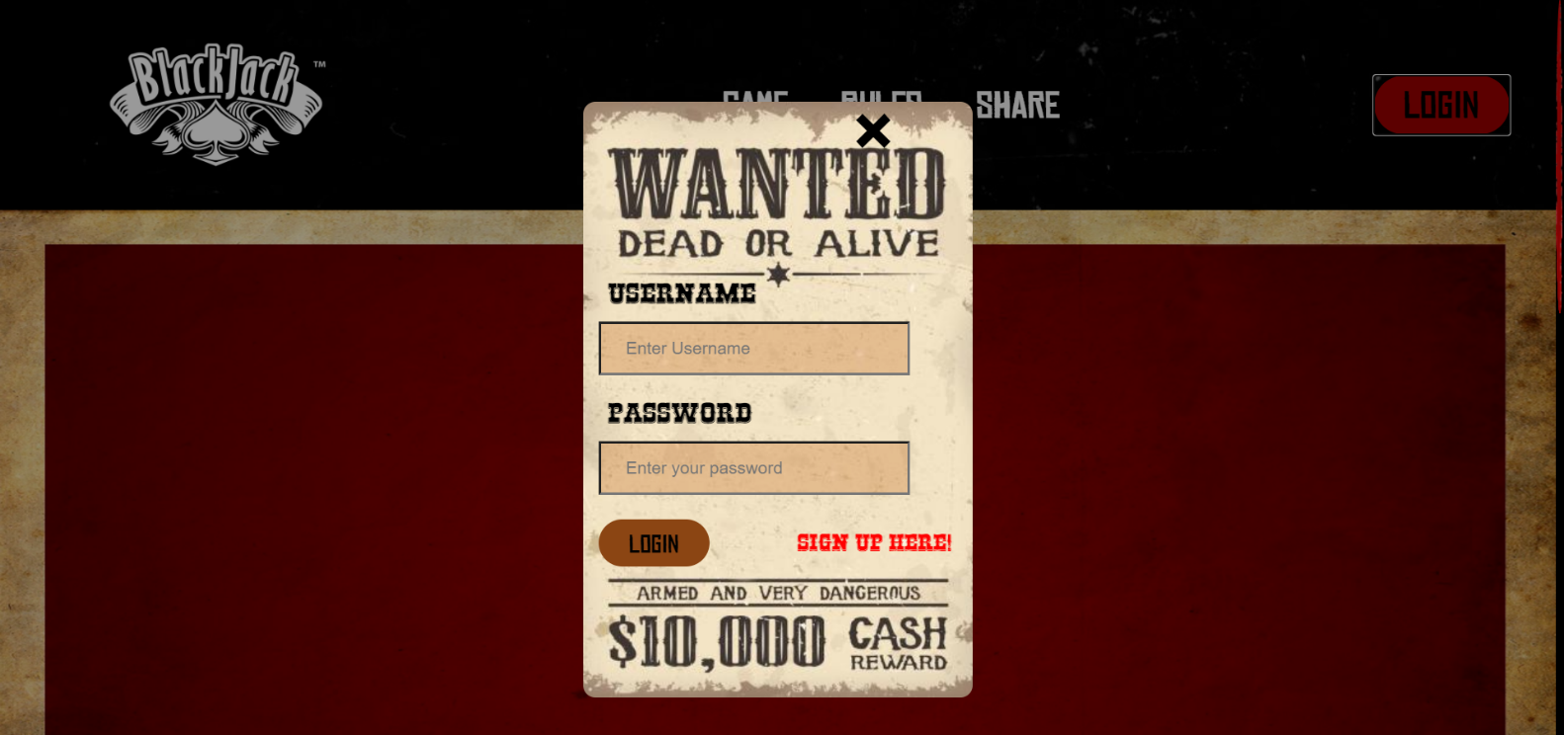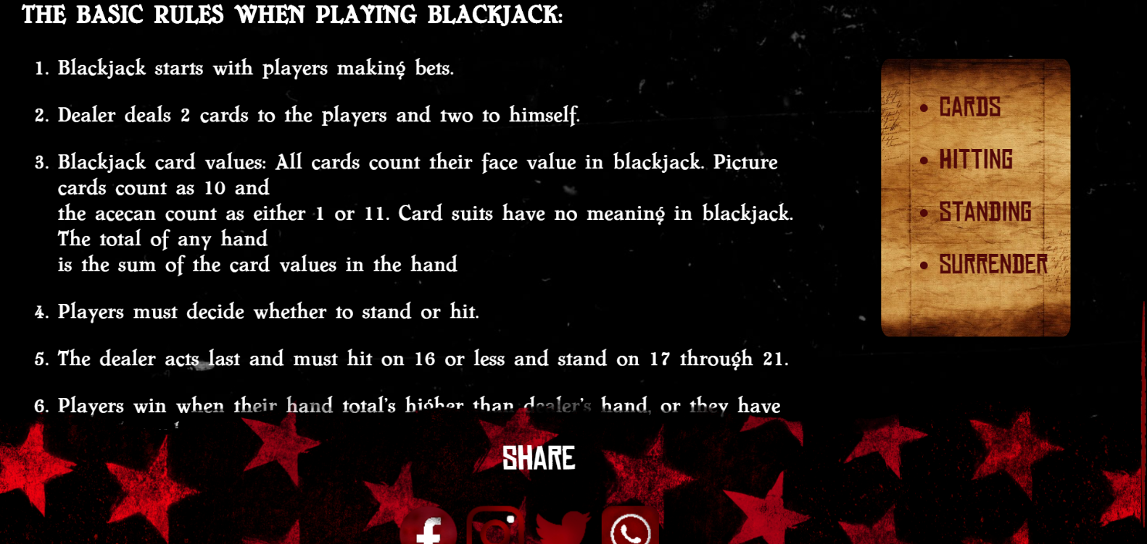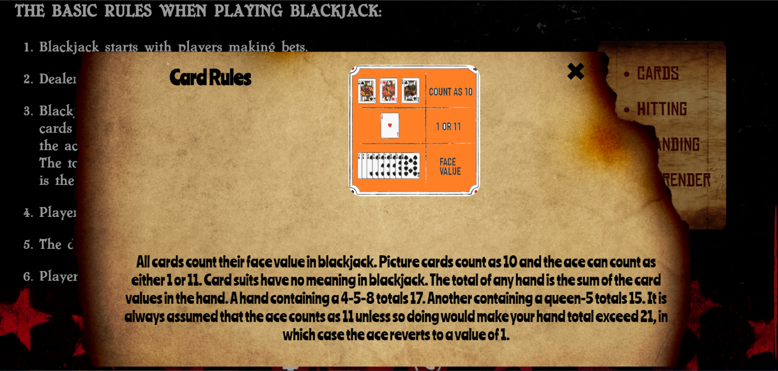

**Conclusion**

1. **Limitation**

* Proposed game consists of only a single deck.
* No real money is involved.
* Proposed game requires an internet connection unless run locally.
* The game lacks certain security feature for login/register.
* The website elements some times do not scale with certain monitor resolutions causing text and image distortions.
* There is no special PUSH concept for draws.
* The user cannot change his username and password once they are sent to the database.
* The above features is not implemented due to design issues on the login popup.

1. **Enhancement**

The proposed system is equipped with all the basic functionalities required to play blackjack.

There is scope for enhancement of the system in the future as well. Some of the factors that are planned to be included in a possible Version are:

* Implement possibility to play multiple decks of cards to emulate modern day casino rules.
* Implement a proper security model for login/register.
* Implement multiple rule sets and create the ability for the player to change between them.
* Have every element on the front-end scale properly with a user’s monitor.
* Use better scripting tools such as jQuery, bootstrap for interaction between front-end and back-end.

**References**

1. **Bibliography**
   * PHP and MySQL Web Development by Welling Thomson Fourth Edition, Pearson publication.
2. **Webliography**

* <https://www.blackjackapprenticeship.com/how-to-play-blackjack/>
* <https://www.php.net/>
* <https://famfonts.com>
* <https://www.mysql.com/>
* <https://www.fontspace.com>
* <https://stackoverflow.com>